**Ansible development using VS Code and GitHub EMU**

Our GitHub repos have migrated to GitHub EMU and this impacts our development process. Please follow the directions below to re-clone the migrated repos to the Ansible development server and to check code changes into the migrated repos.

Old GitHub repo locations (no longer used and will be archived soon):

<https://github.aetna.com/PEDBEngineering/ans_ent_mariadb_playbook>

<https://github.aetna.com/PEDBEngineering/ans_ent_mysql_playbook>

<https://github.aetna.com/PEDBEngineering/ans_ent_postgresql_playbook>

New GitHub EMU repo locations (active and called by Jenkins forms):

<https://github.com/cvs-health-enterprise-code/ans_ent_mariadb_playbook>

<https://github.com/cvs-health-enterprise-code/ans_ent_mysql_playbook>

<https://github.com/cvs-health-enterprise-code/ans_ent_postgresql_playbook>

The first task is to generate a Personal Access Token from your GitHub EMU account as this will be used during git commands for password-less authentication. Select any of the GitHub EMU links above and once in, left-click your profile icon in the top right and select Settings. On the Settings page, scroll all the way to the bottom and select the Developer settings option on the left. On the Developer Settings page, expand Personal access tokens on the left side and select Tokens (classic). Select Generate new token (classic) to create your new Personal Access Token. My example:

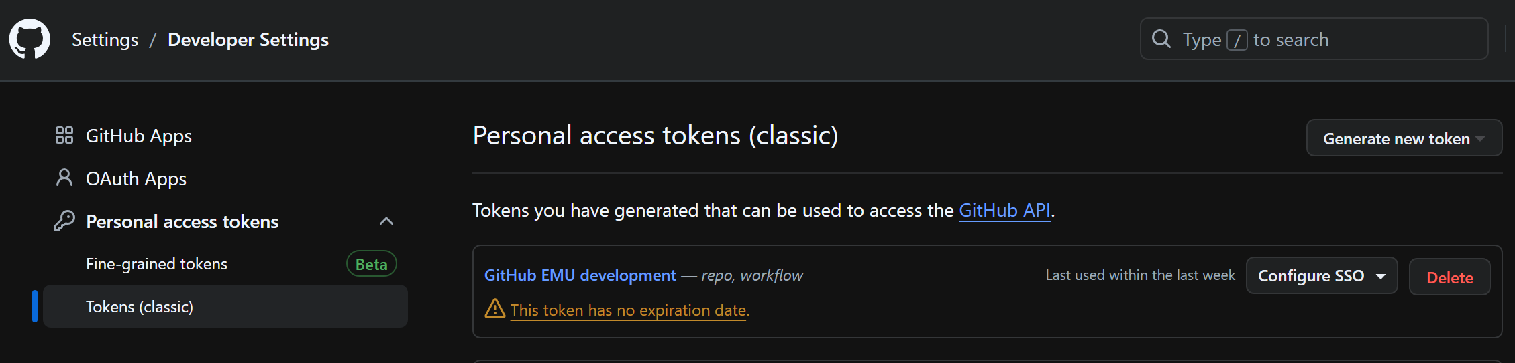

I set mine to unexpiring but was advised that they may enforce expiring Personal Access Tokens in the future. After you create the token select the Configure SSO dropdown and authorize it for SSO.

Next, we need to reconfigure the SSH key in GitHub EMU that should already be present on the development server. From the GitHub EMU Settings page, select SSH and GPG keys. Select the New SSH key button on the right (in green). In the Add new SSH key page, give your key a title (you can name whatever you like) and then paste the contents of the *rsa.pub key file located on the Ansible development server at /users/<A ID>/.ssh. Similar to the Personal Access Token, you will select the Configure SSO dropdown and authorize it for SSO.

Now we need to configure VS Code to be able to reach GitHub EMU. Open a new VS Code session and connect to the Ansible development server (I left-click in the bottom left where the symbol looks like:

Then select Connect to Host and either select or enter xsvcaapm01p.aetna.com. Once connected to the development server, open a Terminal window (View -> Terminal) and run the following command in the Terminal window: git config --global http.proxy http://eastproxies.cvshealth.com:8080

Now that you have a Personal Access Token and VS Code has been configured with the GitHub EMU proxy, we can clone the GitHub EMU repos (please reclone all repos to replace your old ones as they were all modified during the GitHub EMU migration).

I created a new Automation subfolder on the Ansible development server, xsvcaapm01p.aetna.com, named EMU but you can name it whatever works for you. My example: /users/a614623/Automation/EMU

Or you can manually remove your current repos and files from the Ansible development server and re-clone to the same location. I used a new location under EMU directory as it was easier and is clear that these code repos are from GitHub EMU.

Once you have a clean directory to clone to, we can clone the GitHub EMU repos via the VS Code console or manually from the Ansible development server directly using git commands.

To clone a GitHub EMU repo from the VS Code console, select Clone Git Repository from the VS Code Welcome page and when it asks for the URL, enter the repo URL using the following format:

[https://<token>@github.com/cvs-health-enterprise-code/<playbook](https://%3ctoken%3e@github.com/cvs-health-enterprise-code/%3cplaybook)>

Example (without token value): [https://<token>@github.com/cvs-health-enterprise-code/ans_ent_mysql_playbook.git](https://%3ctoken%3e@github.com/cvs-health-enterprise-code/ans_ent_mysql_playbook.git)

For the repo clone destination, select the clean directory dedicated for your repos (/users/a614623/Automation/EMU for example).

To clone the GitHub EMU repo manually from the development server, navigate (cd) to the clean directory dedicated for your repos and run the following commands:

export https_proxy=http://eastproxies.cvshealth.com:8080

git clone [https://<token>@github.com/cvs-health-enterprise-code/<playbook](https://%3ctoken%3e@github.com/cvs-health-enterprise-code/%3cplaybook)>

Whichever method you choose, you will need to provide your Personal Access Token.

I suggest using the VS Code console option to clone the GitHub EMU repos as this will allow you to push/pull code changes from the VS Code console the same as we did before. Reminder that after cloning the GitHub EMU repo in the VS Code console, create a branch (outside of master) to make your code changes to like we did before. The first time you check in code from your new branch, it will say Publish Branch to send your repo branch to GitHub EMU where you will then merge it into the master branch like we did before.

For manual pushes to GitHub EMU directly from the Ansible development server outside of VS Code, you will have to use git commands to create your branch, stage changes, commit changes and push to GitHub EMU.

Manual commands from inside repo directory on development server:

export https_proxy=http://eastproxies.cvshealth.com:8080

git checkout -b <branch name> <- create and switch to branch

git add . <- stage changes

git commit -m “<comment>” <- commit changes

git push --set-upstream https://<token>@github.com/cvs-health-enterprise-code/<playbook> <branch name>

Then login to GitHub EMU and confirm your branch and merge it into master.

Please reach out to Tim Long with any questions.